Why do I need a Trade Name?
Confused about the whole “Trade Name” field in the Trade Journals and Daily Trade Log? Not really sure why you need one or how to create it? Excellent questions! There are actually lots of reasons, many of which we’ll get into when we dive into reporting. But let’s start with a really easy answer – it’s the very best way to do a trade debrief.
Let’s say that you’ve been successfully journaling for a while and have several trades entered, with some open and some closed. You’ll have Daily Trade Log entries for every day, so when you go to the View Entries screen, you’ll see LOTS of entries for LOTS of trades. Messy!

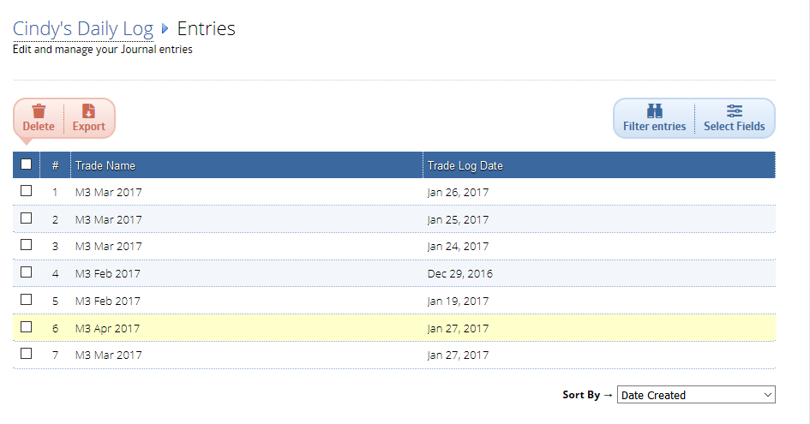

What if you want to do a trade debrief (because you do, right?) and only see the Daily Logs for a single trade? That’s where Filter Entries comes in handy. If you want to do a trade debrief on your March M3, you can filter entries, like this:

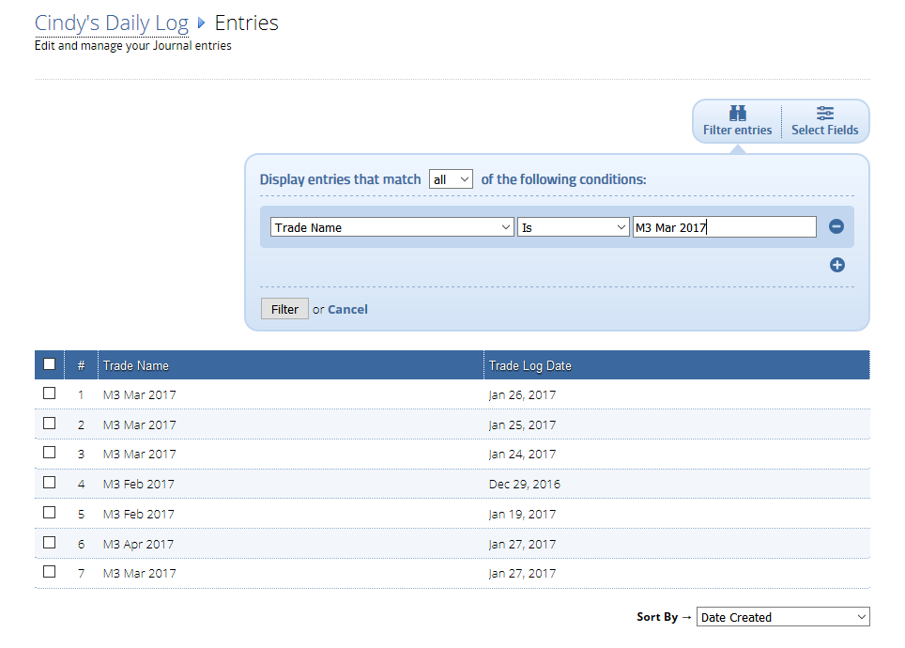

If you fill in the top condition and then click the Filter button, you get the following results:

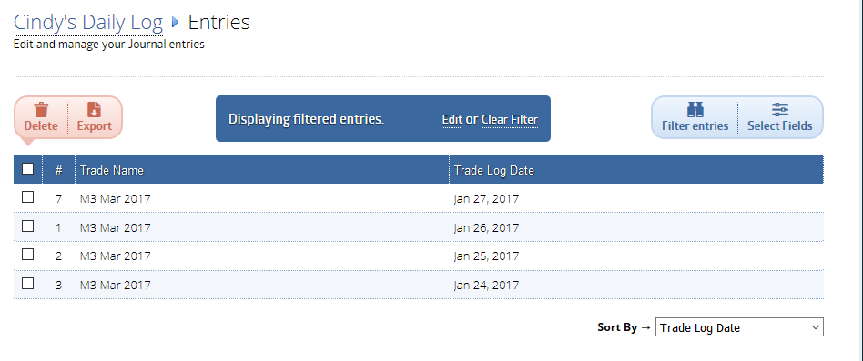

Note that I also used the Sort By function at the bottom to sort them by Trade Log Date (descending). Now all you need to do is click into the first one, then use the and arrows to scroll day by day.
